1. configuration of network devices using cisco packet tracer .

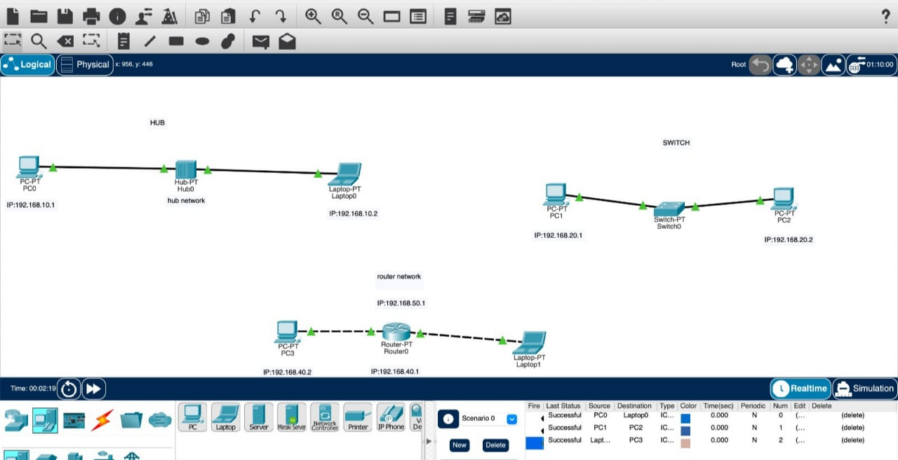

2 .Design and configuration of star topologies.

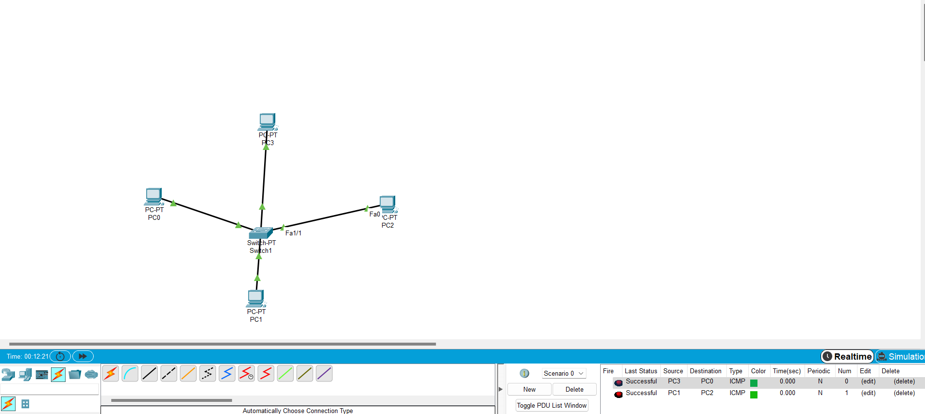

3.Design and configuration of bus topology.

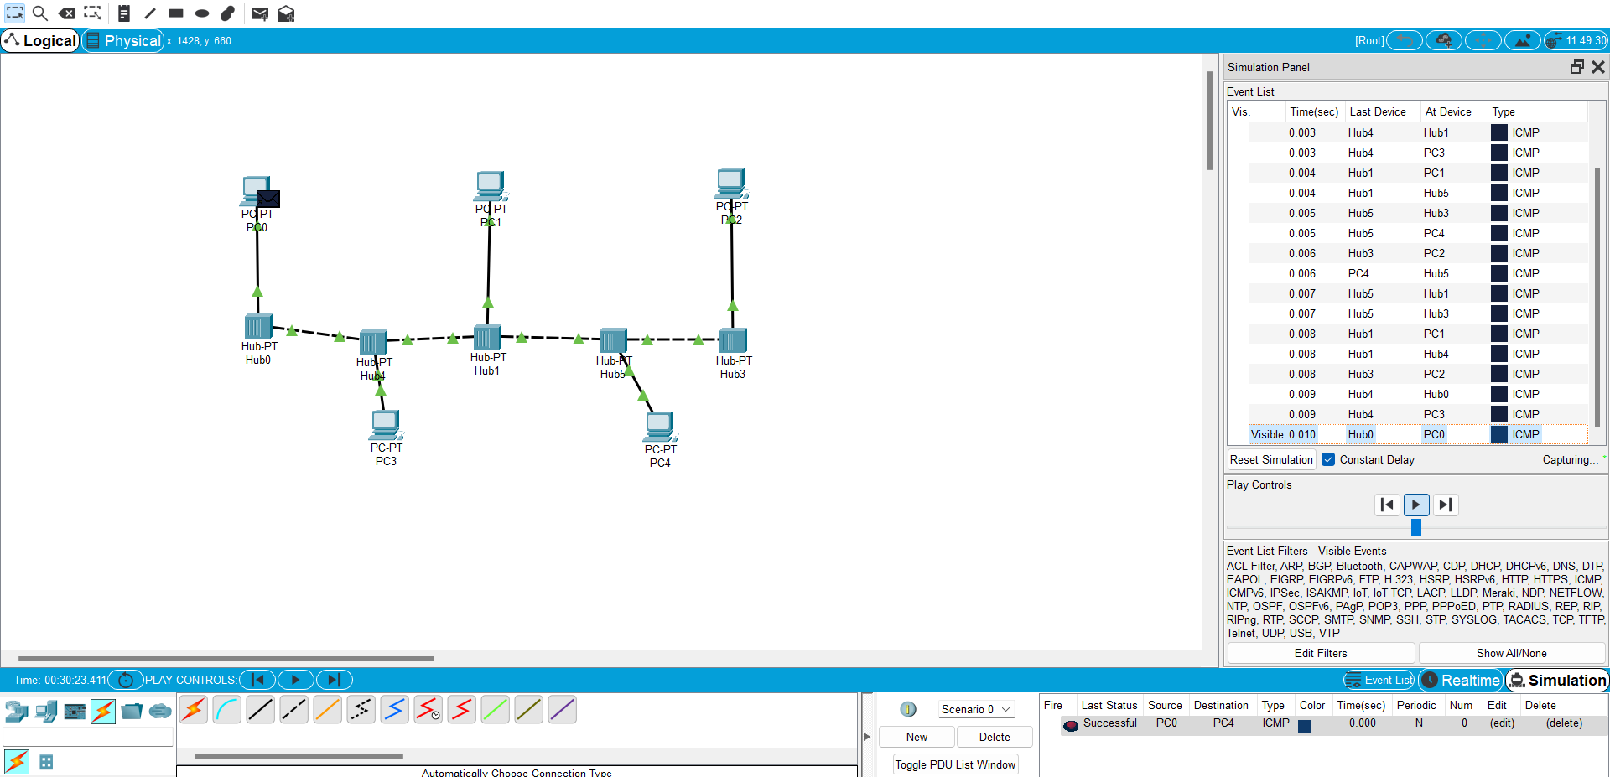

4.Design and configuration of ring topology.

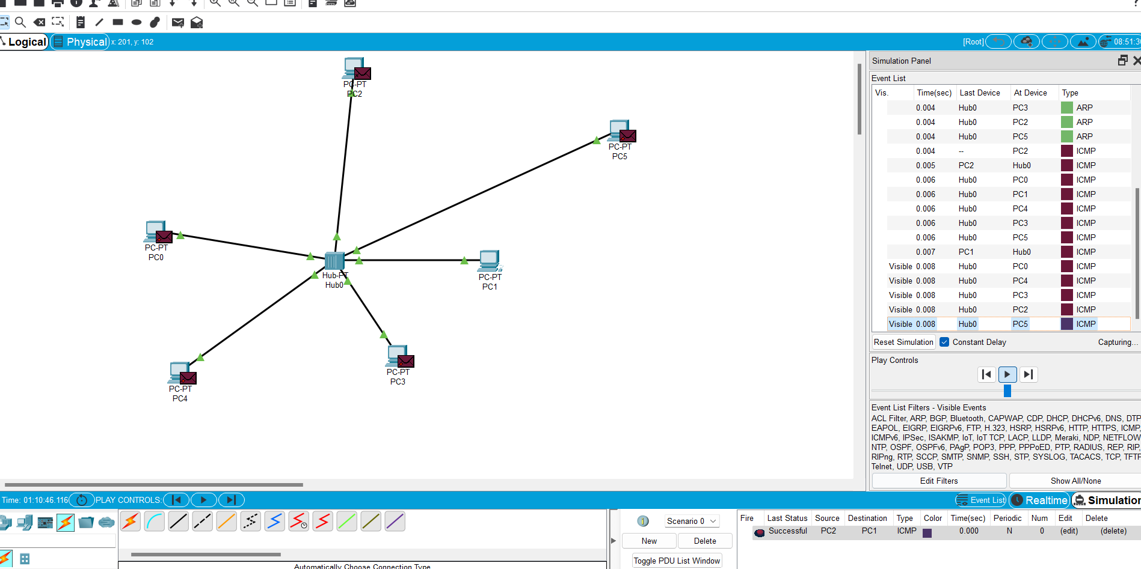

5.Design and configuration of mesh topology.

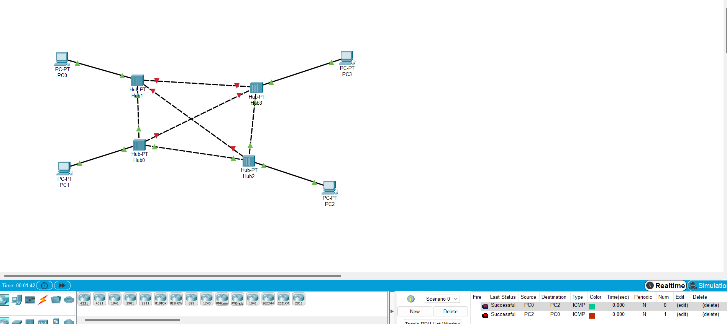

6.Design and configuration of tree topology.

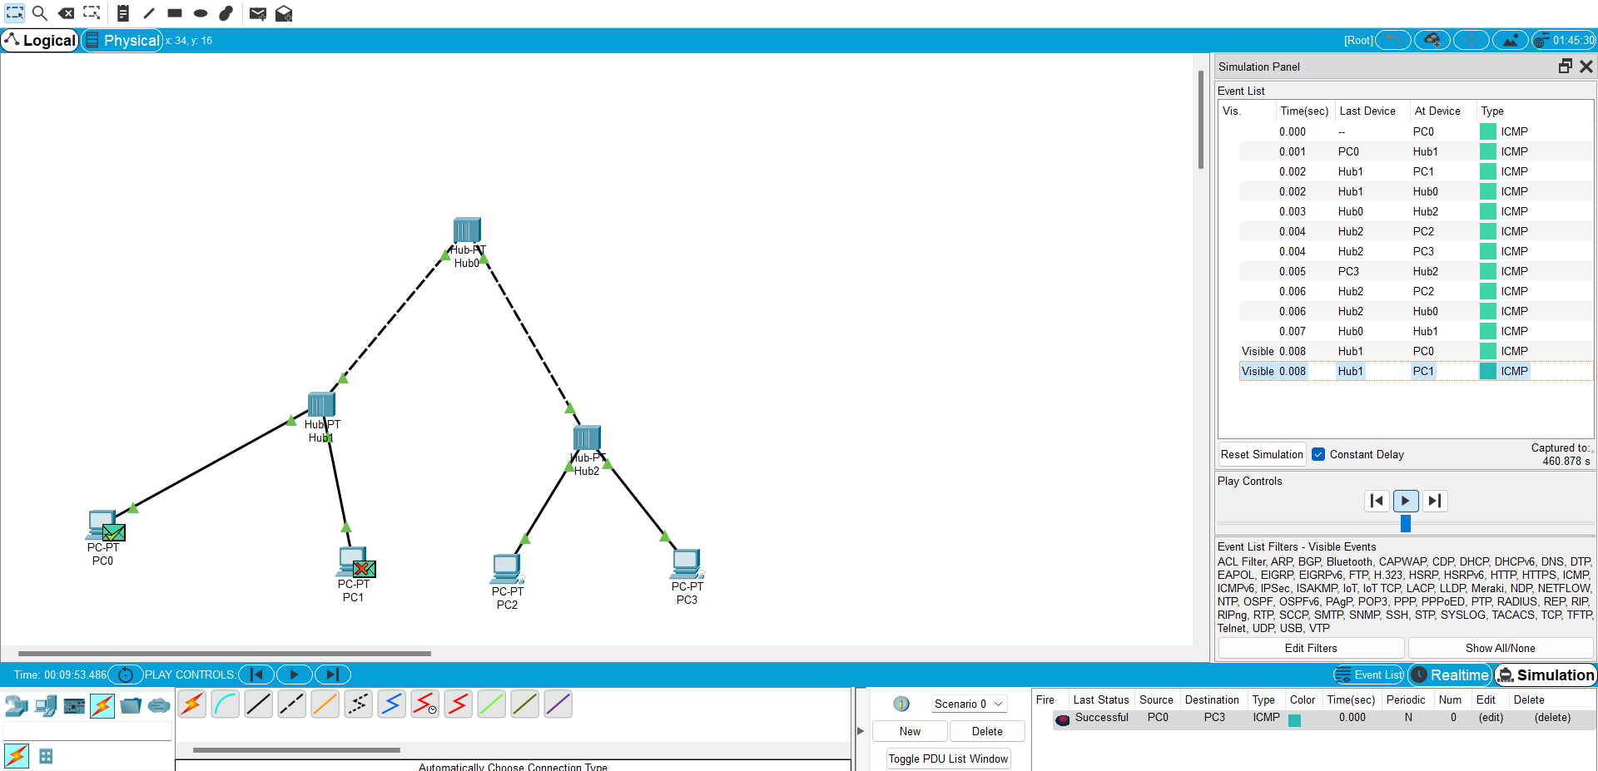

7.Design and configuration of hybrid topology.

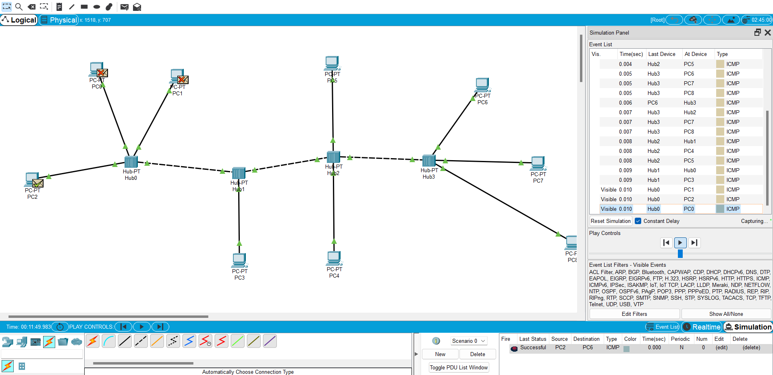

8.Data link layer simulating using packet tracer of ARP and LLDP

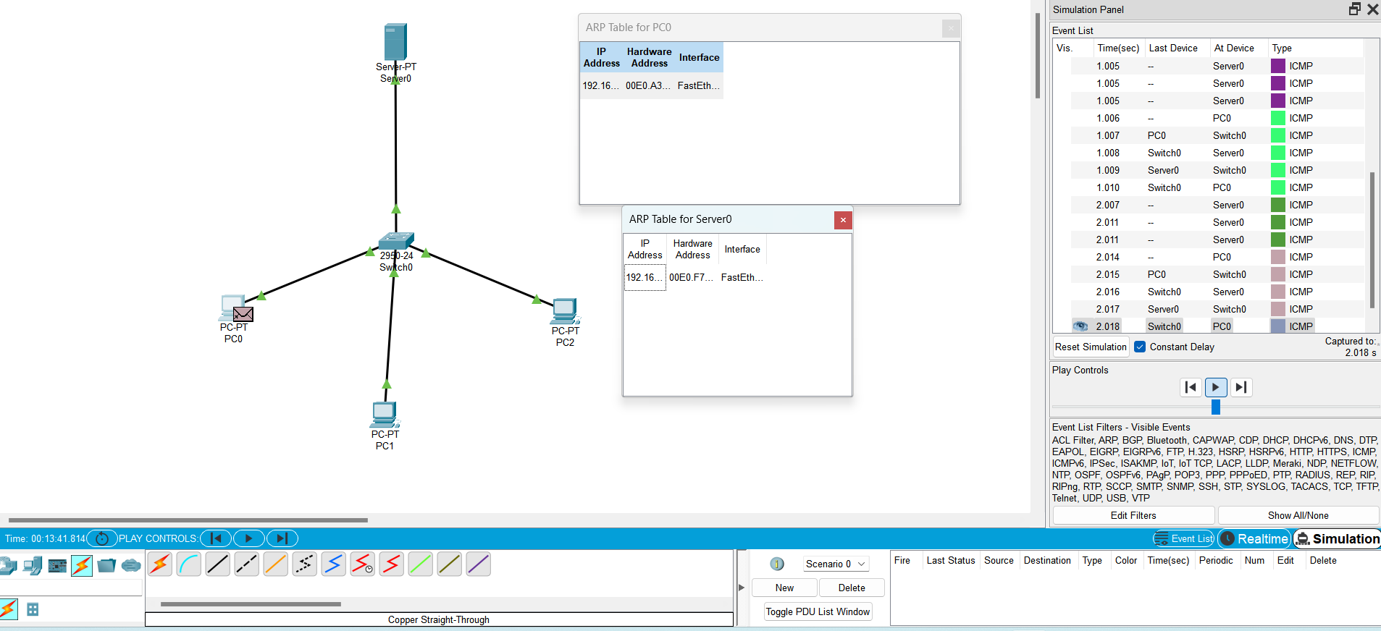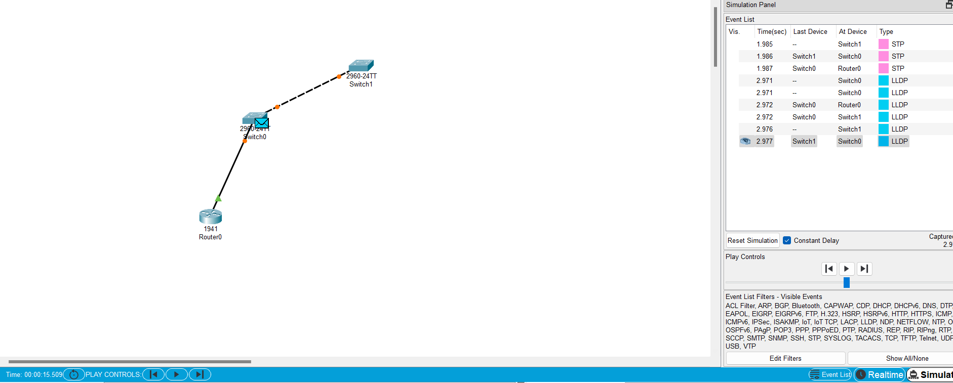

9.Data link layer traffic simulation using packet tracer of CSMA/CD and CSMA/CA.

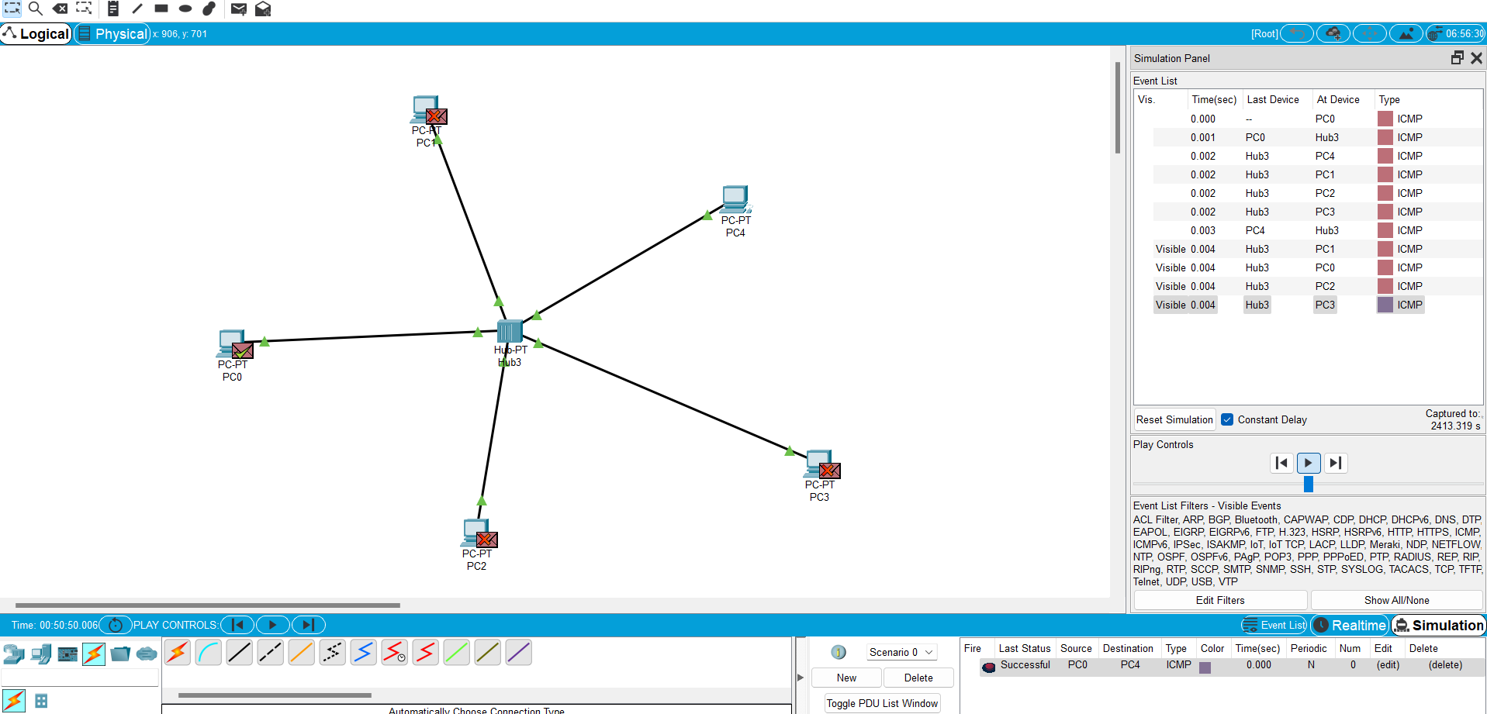

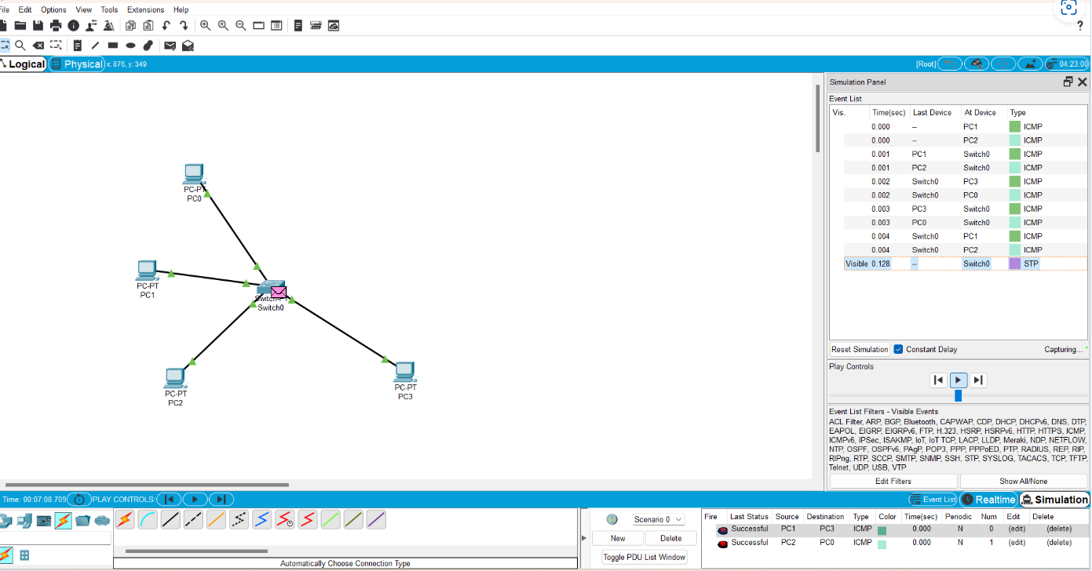

10.Designing two different network with static routing techniques.

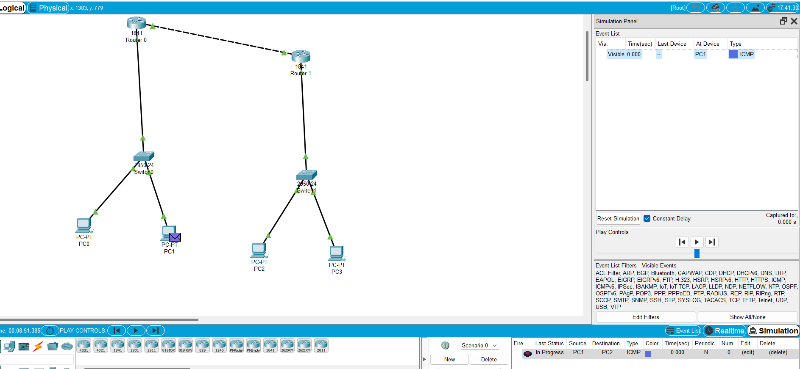

11.Functionalities and exploration of TCP.

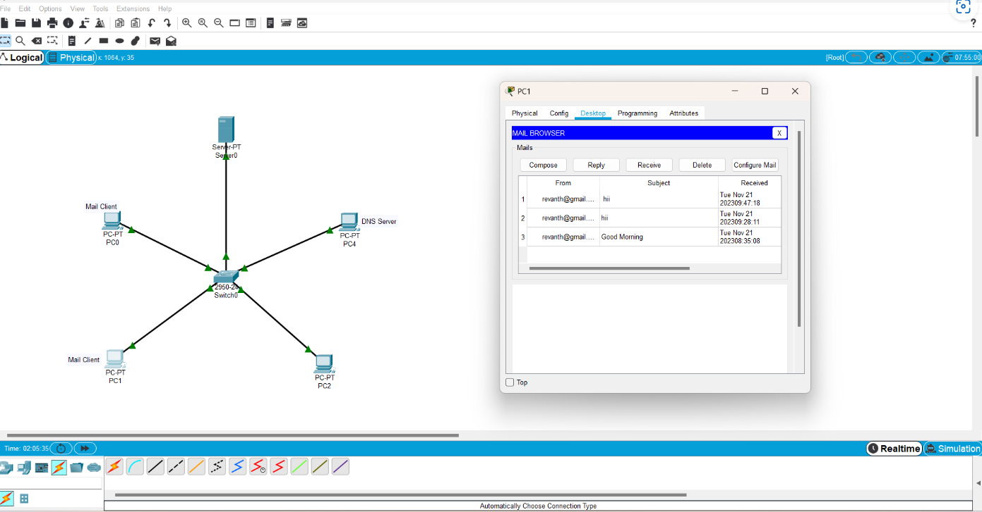

12.Design and network model for subnetting -class C addressing.

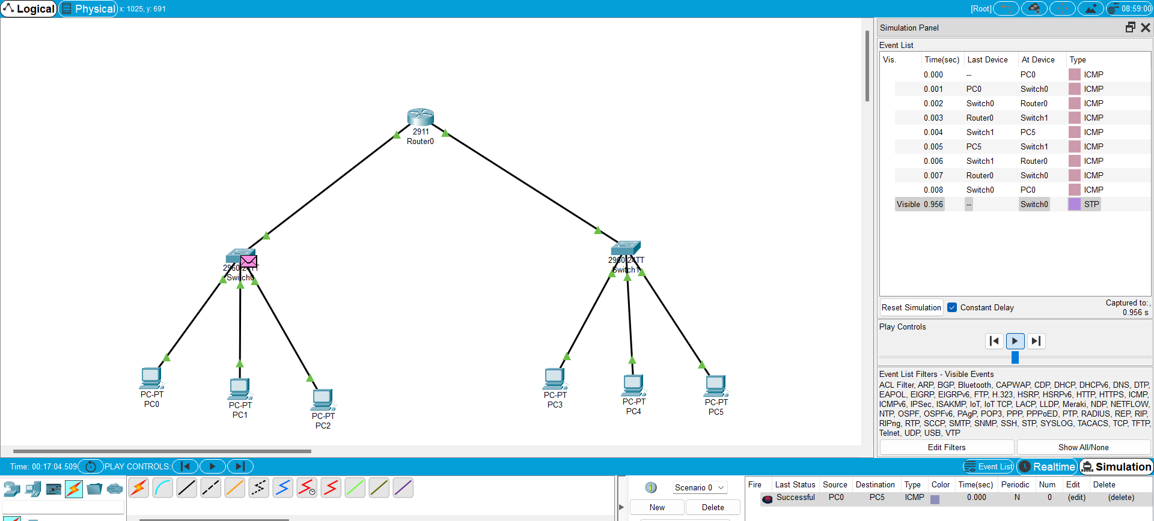

13.Simulatind a network design for X,Y,Z company using packet tracer.

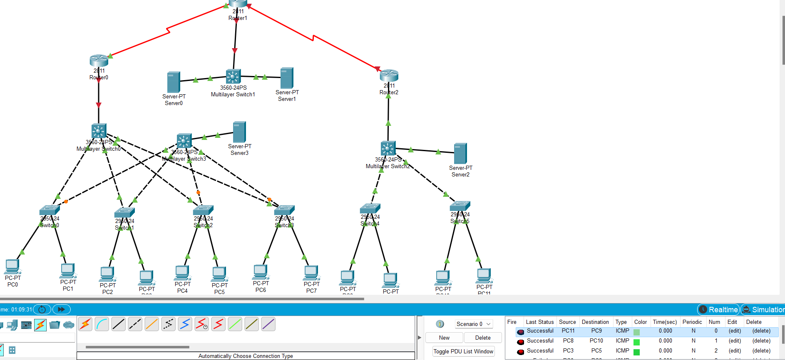

14.configuration of DHCP using packet tracer.

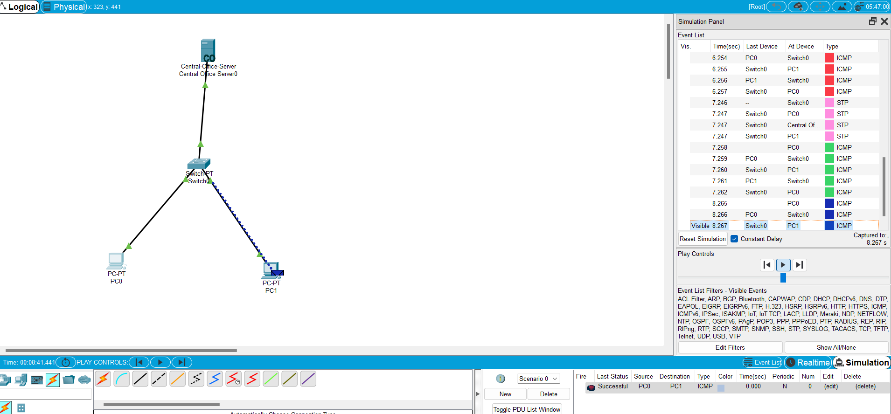

15.IoT based smart home appliances.

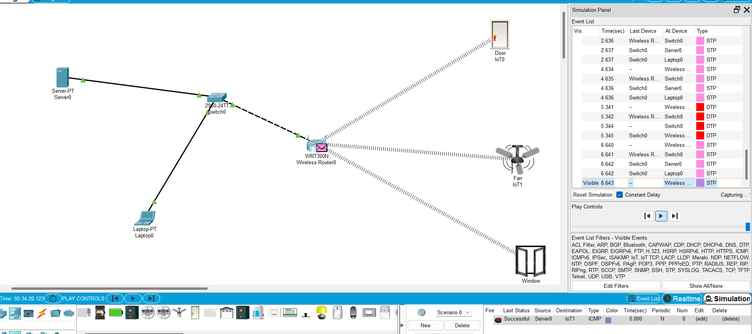

16.Implementation of IoT based smart gardening.

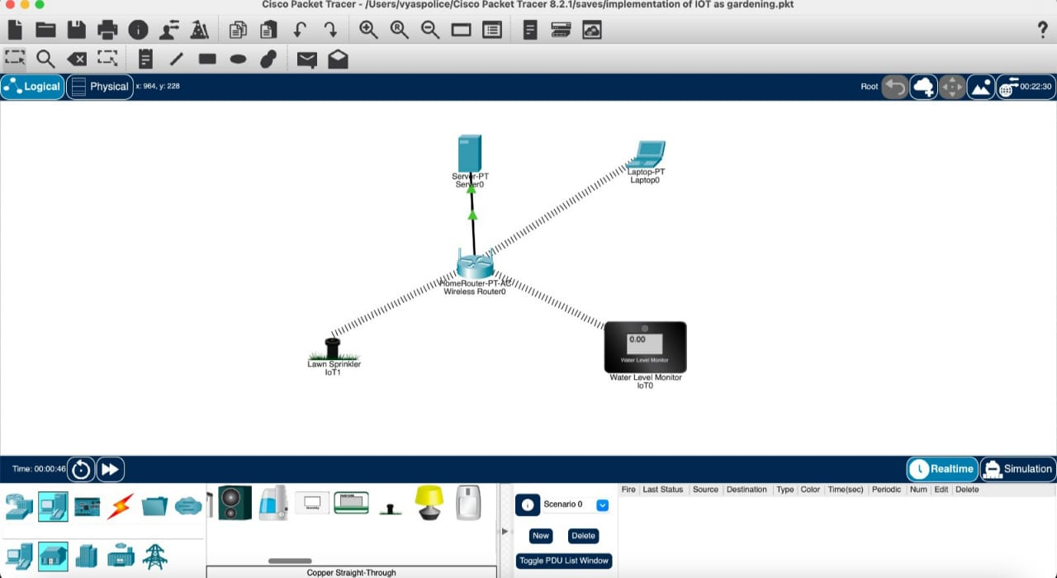

17.Transport layer protocol using wireshark-TCP and UDP.

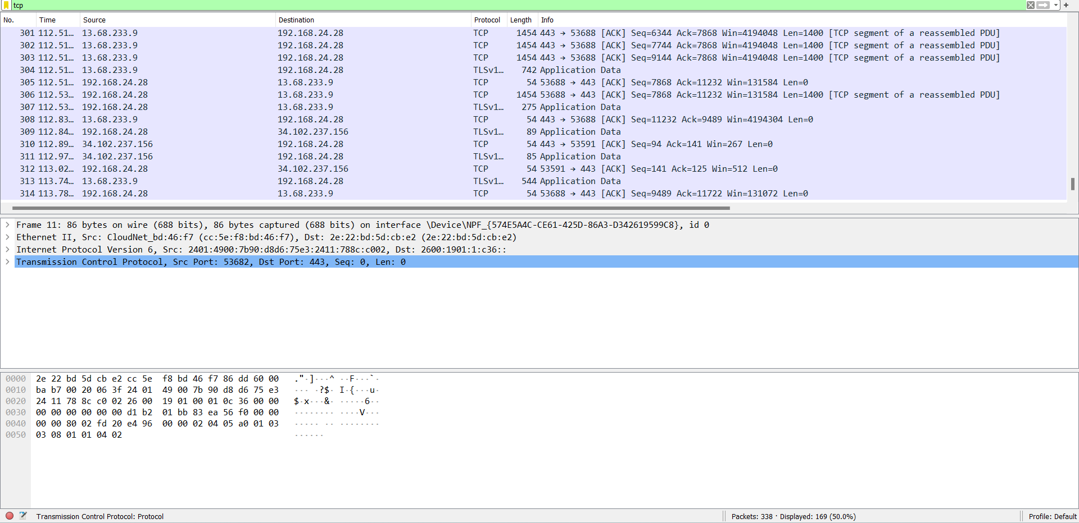

18.Network layer protocol using wireshark –SMTP and ICMP.

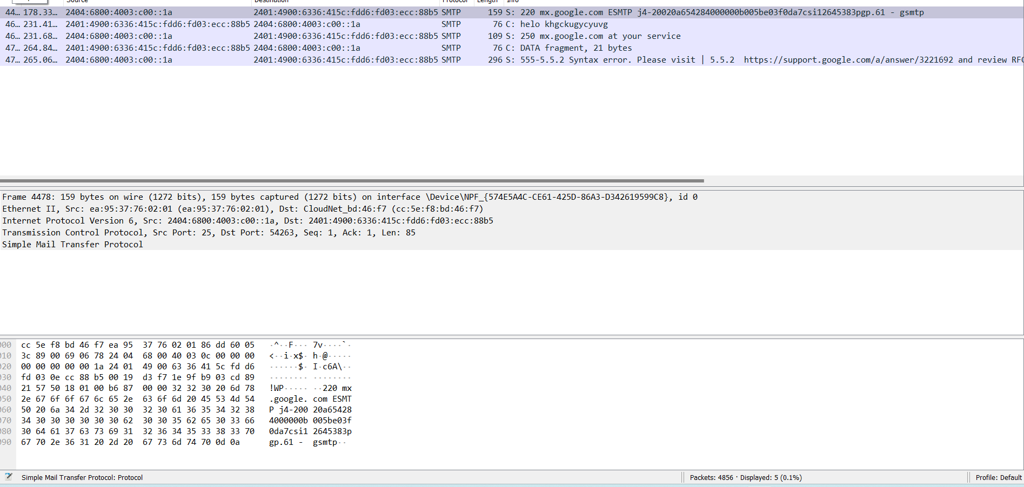

19.Network layer protocol header using wireshark-ARP and HTTP.

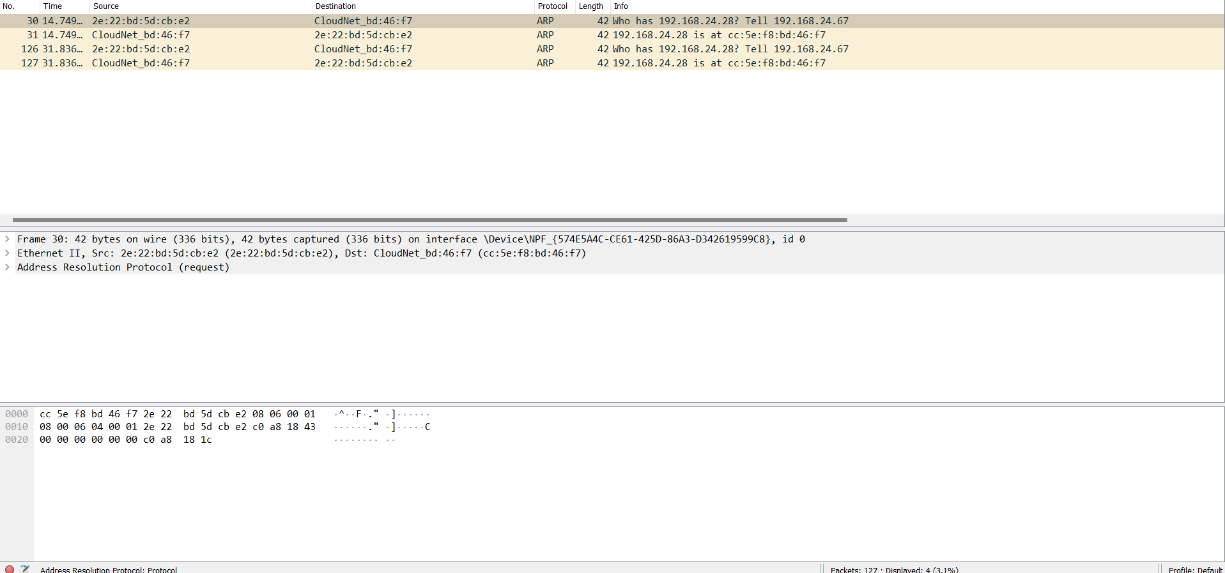

20.Implementation of bit stuffing mechanism using C.

